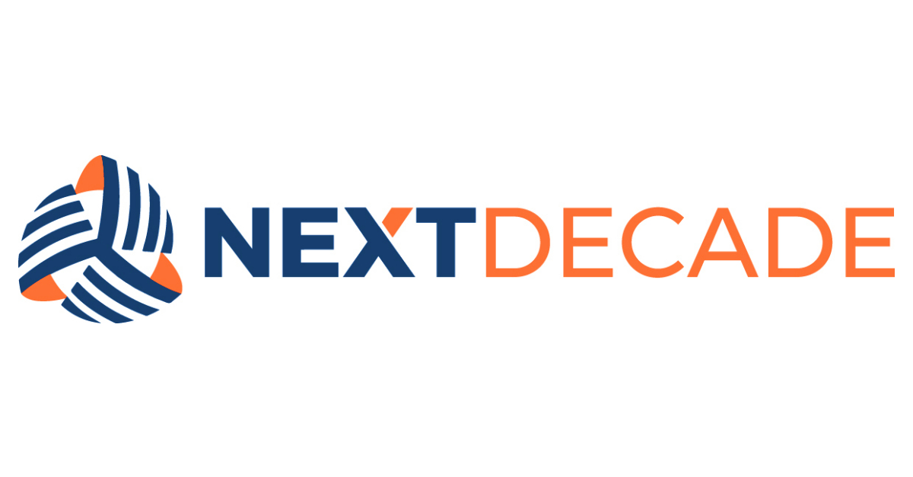

NAME
PROCEDURE DOCUMENT
xxx-xxx-xxx-xxx-xxx-#####

Table of Contents

1. PURPOSE 3
2. SCOPE 3
3. INTEGRATED GOVERNANCE FRAMEWORK 3
4. DEFINITIONS 3
5. REFERENCES AND RELATED DOCUMENTS 3
6. [CONTENT TITLE] 3
7. [CONTENT TITLE] 4
8. EXCEPTION REQUEST AND COMPLIANCE AUDITS 4
9. CONTINUOUS IMPROVEMENT AND REVIEW 4
10. OWNERSHIP 4
11. APPROVAL 4
REVISION HISTORY 5

PURPOSE
The purpose of the [Name the Procedure] (“Procedure”) [Describe the Purpose]. Compliance with the Procedure is mandatory as governed by the [Name the Standard the Procedure Links To].

SCOPE
This Procedure outlines ‘Step-by-Step Instructions’ detailing [Describe the Area of Instruction]. The Procedure applies to all employees, officers, directors, agents, consultants, contractors, and representatives, and any other individuals when they act on behalf of the Company (collectively “Workforce”).

INTEGRATED GOVERNANCE FRAMEWORK
This Procedure is part of NextDecade’s integrated Governance Framework. The Workforce must understand and comply with this Procedure and all other Governance Framework Policies, Standards, and Procedures.

DEFINITIONS
No. | Term | Definition

REFERENCES AND RELATED DOCUMENTS
Title | Document Number

[CONTENT TITLE]
[Content Description]
  - [Content Detail]
    - [Content Detail]
      - [Content Detail]

[CONTENT TITLE]
[Content Description]
  - [Content Detail]
    - [Content Detail]
      - [Content Detail]

EXCEPTION REQUEST AND COMPLIANCE AUDITS
When compliance is not feasible or technically possible or when deviation is necessary to support a business function, requests for exceptions to any term or requirement of this Procedure must be made to the [Name Party / Role]. The Company will work in good faith to address the exception request but reserves the right to require compliance with this Procedure in all cases.

CONTINUOUS IMPROVEMENT AND REVIEW
This Procedure will be reviewed at least annually to ensure it remains current and relevant. The Workforce will be informed of any significant revisions in a timely manner.

OWNERSHIP
Responsible | Accountable | Consulted | Informed

APPROVAL
Issuer / Title | Adopted By | Effective / Amended Date
s/ | NextDecade Corporation

REVISION HISTORY

Revision | Description of Changes and Notes
0 | Issued for Use

The Governance Framework outlines the rules, practices, and processes by which the Company is directed and controlled ensuring accountability, fairness, and transparency in the Company's relationship with its stakeholders, including shareholders, employees, customers, and the community.

